# SQL Exercises on Movie Database

## Using below ERD diagram and Sample Data.

## 

1. Write a query in SQL to find the name and year of the movies.#

SELECT mov_title, mov_year FROM movie;



1. Write a query in SQL to find the year when the movie American Beauty released.

SELECT mov_year FROM movie WHERE mov_title='American Beauty';



1. Write a query in SQL to find the movie which was released in the year 1999.

SELECT mov_title FROM movie WHERE mov_year=1999;

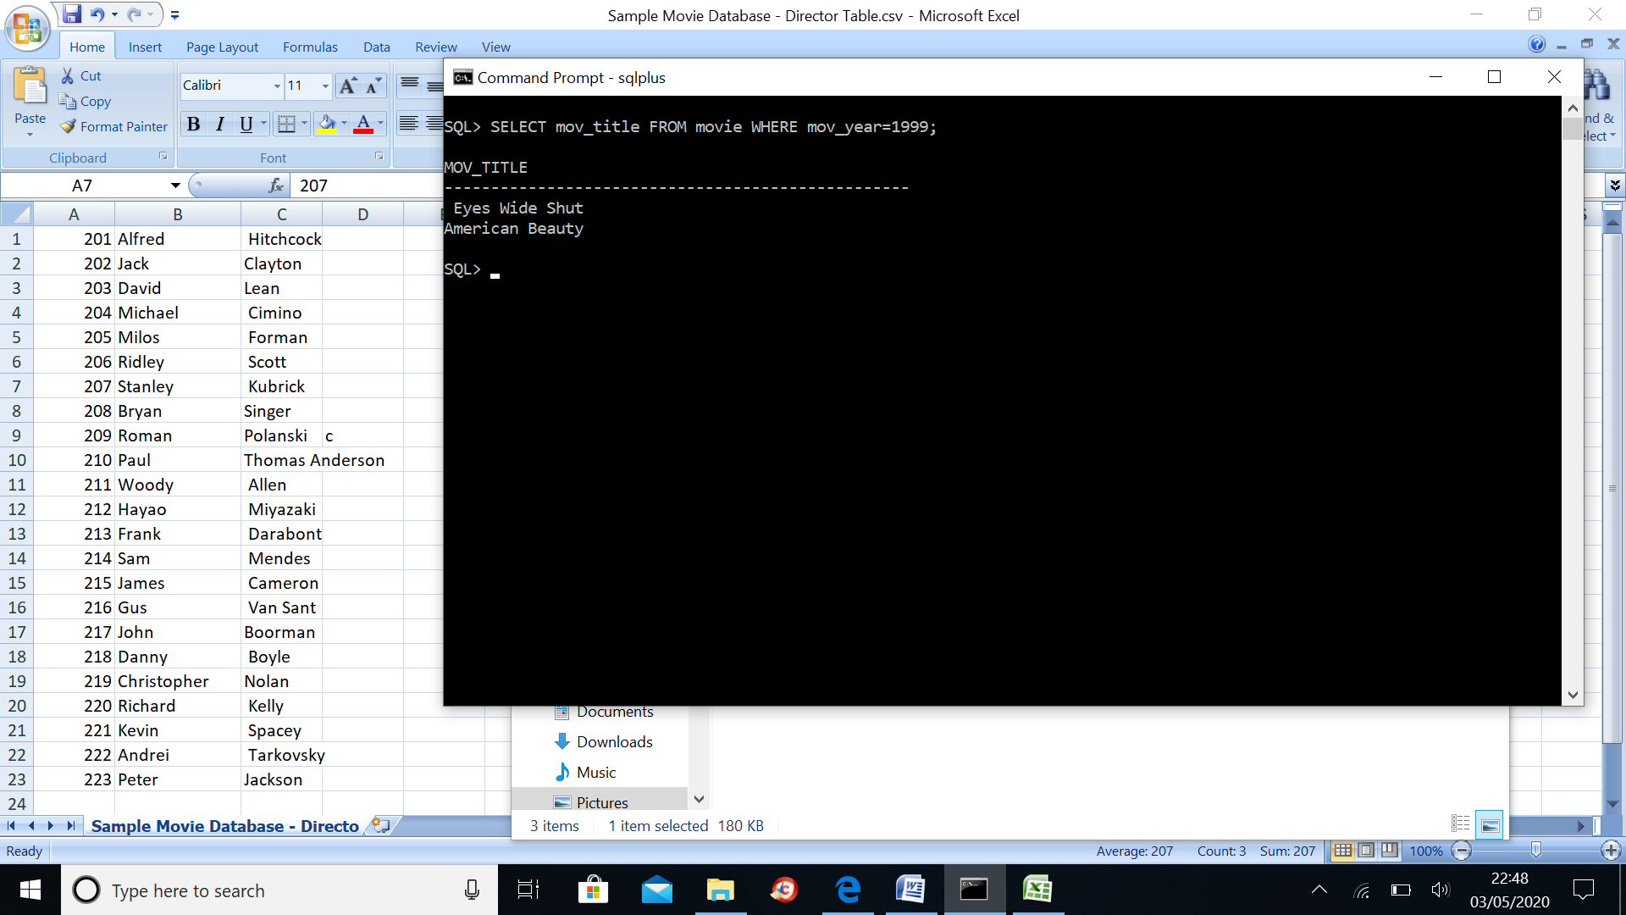

1. Write a query in SQL to return the name of all reviewers and name of movies together in a single list.

SELECT reviewer.rev_name FROM reviewer UNION (SELECT movie.mov_title FROM movie);





1. Write a query in SQL to find the titles of the movies with ID 905, 907, 917.

SELECT mov_title

FROM movie

WHERE mov_id in (905, 907, 917);

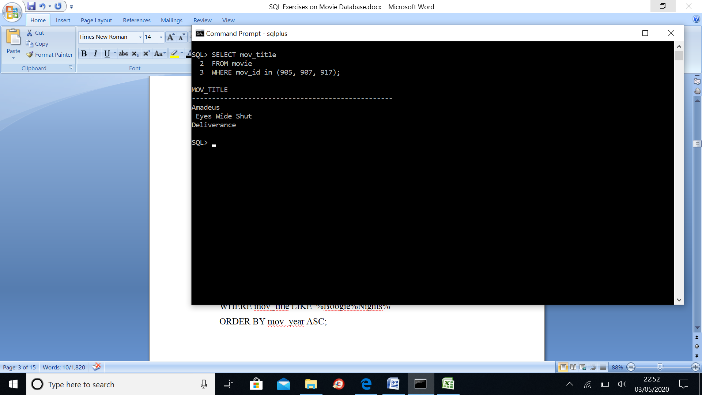

1. Write a query in SQL to find the list of all those movies with year which include the words Boogie Nights.

SELECT mov_id, mov_title, mov_year FROM movie WHERE mov_title LIKE '%Boogie%Nights%' ORDER BY mov_year ASC;

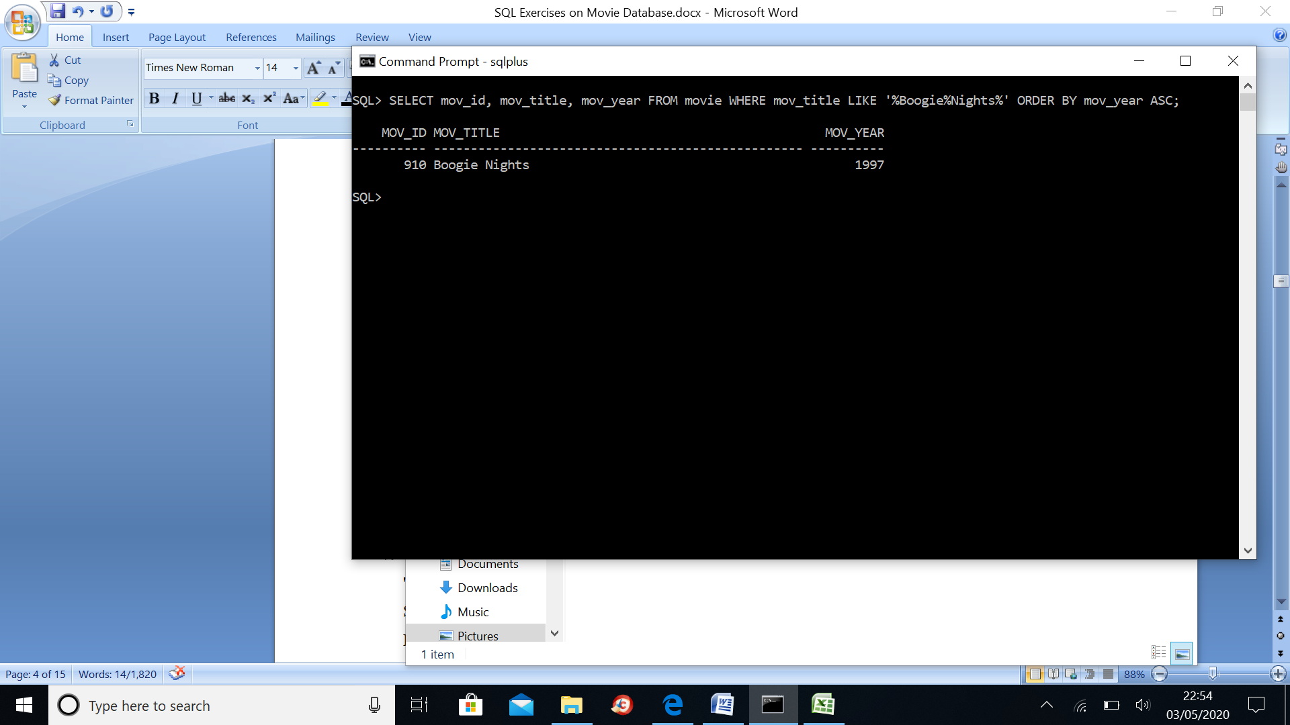

1. Write a query in SQL to find the ID number for the actor whose first name is 'Woody' and the last name is 'Allen'.

SELECT act_id FROM actor WHERE act_fname='Woody’ AND act_lname='Allen';

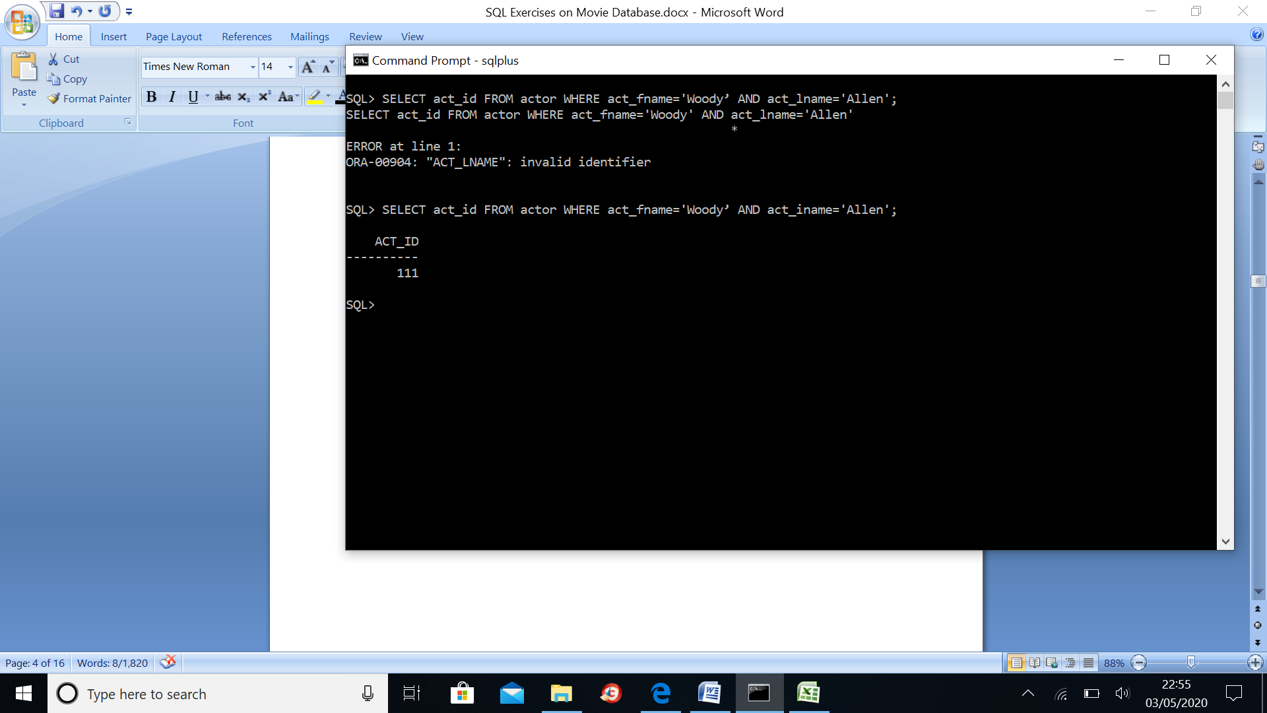

1. Write a query in SQL to find the name of the director (first and last names) who directed a movie that casted a role for 'Eyes Wide Shut'. (using subquery).

SELECT dir_fname, dir_lname, mov_title FROM director NATURAL JOIN movie_direction NATURAL JOIN movie NATURAL JOIN movie_cast WHERE role IS NOT NULL AND mov_title='Eyes Wide Shut';



1. Write a query in SQL to list all the movies which released in the country other than UK.

SELECT mov_title, mov_year, mov_time, mov_dt_rel AS Date_of_Release, mov_rel_country AS Releasing_Country FROM movie WHERE mov_rel_country<>'UK';

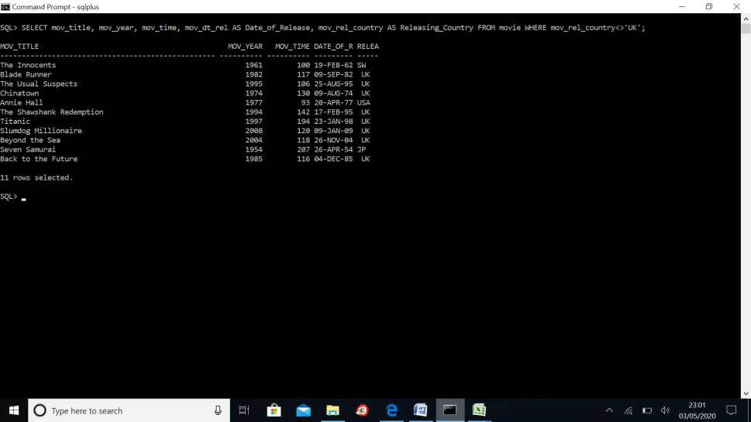

1. Write a query in SQL to find the titles of all movies directed by the director whose first and last name are Woddy Allen.

SELECT mov_title FROM movie WHERE mov_id=(SELECT mov_id FROM movie_direction WHERE dir_id=(SELECT dir_id FROM director WHERE dir_fname='Woody' AND dir_lname='Allen'));



1. Write a query in SQL to find all the years which produced at least one movie and that received a rating of more than 3 stars. Show the results in increasing order.

SELECT DISTINCT mov_year FROM movie WHERE mov_id IN (SELECT mov_id FROM rating WHERE rev_stars>3) ORDER BY mov_year;



1. Write a query in SQL to find the names of all reviewers who have ratings with a NULL value.

SELECT rev_name FROM reviewer INNER JOIN rating USING(rev_id) WHERE rev_stars IS NULL;

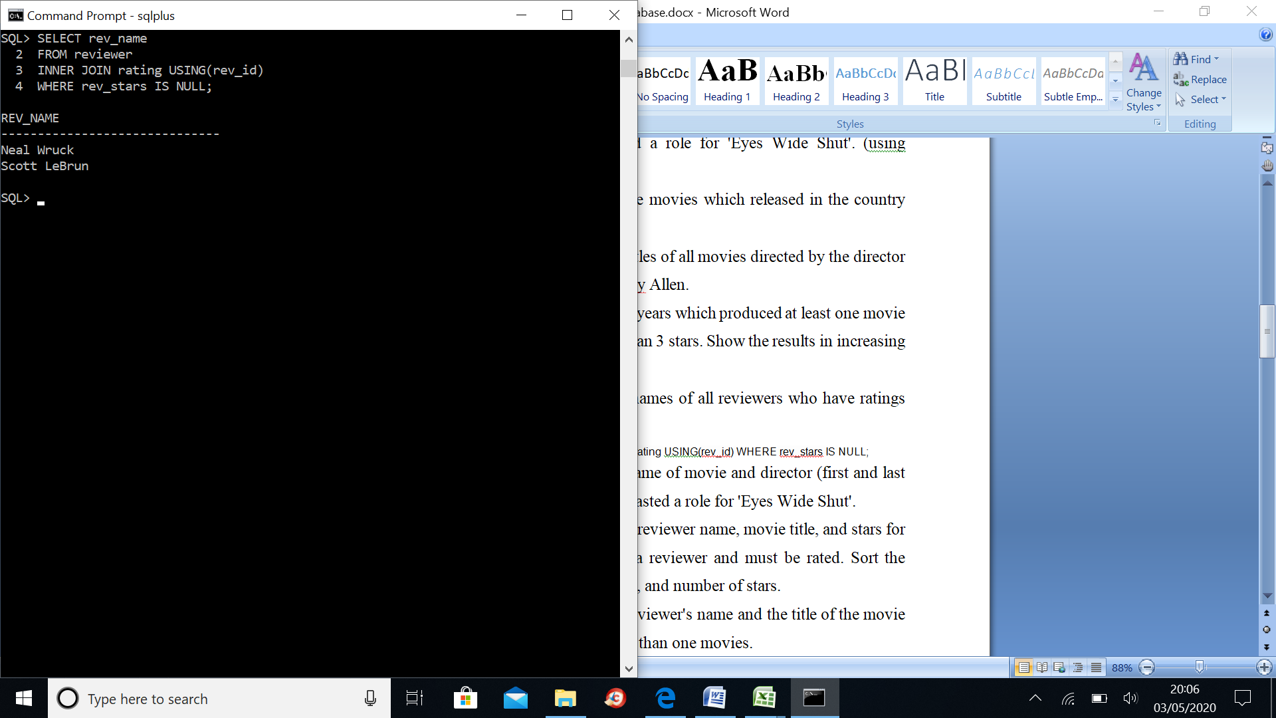

1. Write a query in SQL to find the name of movie and director (first and last names) who directed a movie that casted a role for 'Eyes Wide Shut'.

SELECT dir_fname, dir_lname, mov_title FROM director NATURAL JOIN movie_direction NATURAL JOIN movie NATURAL JOIN movie_cast WHERE role IS NOT NULL AND mov_title='Eyes Wide Shut';



1. Write a query in SQL to return the reviewer name, movie title, and stars for those movies which reviewed by a reviewer and must be rated. Sort the result by reviewer name, movie title, and number of stars.

SELECT rev_name, mov_title, rev_stars FROM reviewer, rating, movie WHERE reviewer.rev_id=rating.rev_id AND movie.mov_id=rating.mov_id AND reviewer.rev_name IS NOT NULL AND rating.rev_stars IS NOT NULL ORDER BY rev_name, mov_title, rev_stars;

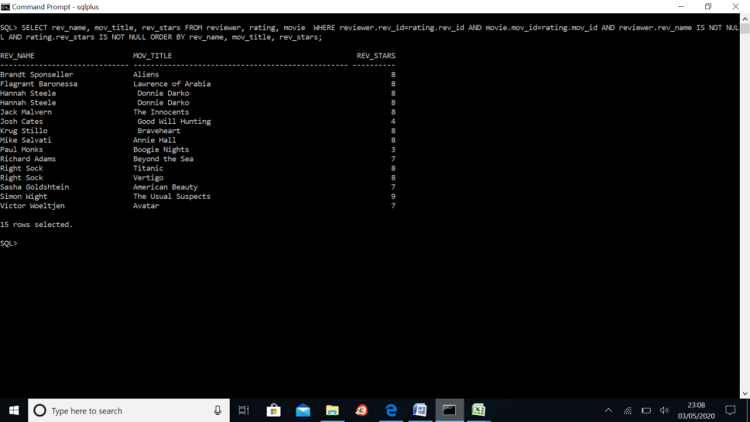

1. Write a query in SQL to find the reviewer's name and the title of the movie for those reviewers who rated more than one movies.

SELECT rev_name, mov_title FROM reviewer, movie, rating, rating r2 WHERE rating.mov_id=movie.mov_id AND reviewer.rev_id=rating.rev_ID AND rating.rev_id = r2.rev_id GROUP BY rev_name, mov_title HAVING count(*) > 1;

~~~~

1. Write a query in SQL to list the first and last names of all the actors who were cast in the movie 'Annie Hall', and the roles they played in that production.

SELECT act_fname,act_lname,role FROM actor JOIN movie_cast ON actor.act_id=movie_cast.act_id JOIN movie ON movie_cast.mov_id=movie.mov_id AND movie.mov_title='Annie Hall';



1. Write a query in SQL to find the movie title, and the highest number of stars that movie received and arranged the result according to the group of a movie and the movie title appear alphabetically in ascending order.

SELECT mov_title, MAX(rev_stars) FROM movie, rating WHERE movie.mov_id=rating.mov_id AND rating.rev_stars IS NOT NULL GROUP BY mov_title ORDER BY mov_title;



1. Write a query in SQL to find the titles of all movies which have been reviewed by anybody except by Paul Monks.

SELECT movie.mov_title FROM movie WHERE movie.mov_id IN(SELECT mov_id FROM rating WHERE rev_id NOT IN (SELECT rev_id FROM reviewer WHERE rev_name='Paul Monks'));



1. Write a query in SQL to find the name of all reviewers who have rated their ratings with a NULL value.

SELECT rev_name FROM reviewer INNER JOIN rating USING(rev_id) WHERE rev_stars IS NULL;



1. Write a query in SQL to return the reviewer name, movie title, and number of stars for those movies which rating is the lowest one.

SELECT rev_name, mov_title, rev_stars FROM reviewer, rating, movie WHERE reviewer.rev_id=rating.rev_id

AND movie.mov_id=rating.mov_id AND reviewer.rev_name IS NOT NULL AND rating.rev_stars IS NOT NULL ORDER BY rev_name, mov_title, rev_stars;

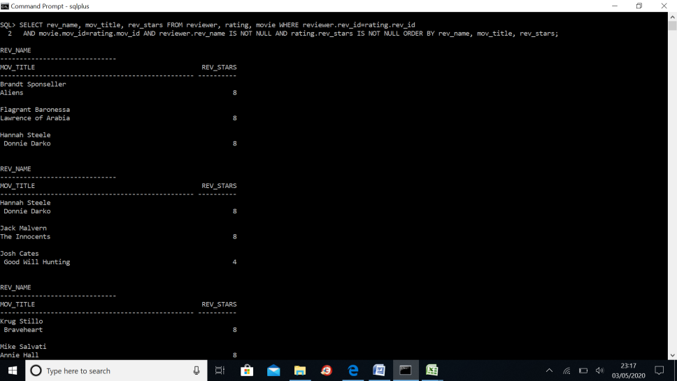



1. Write a query in SQL to find the titles of all movies directed by James Cameron.

SELECT mov_title FROM movie WHERE mov_id IN (SELECT mov_id

FROM movie_direction WHERE dir_id IN (SELECT dir_id FROM director WHERE dir_fname = 'James' AND dir_lname='Cameron'));



1. Write a query in SQL to find the name of movie and director (first and last names) who directed a movie that casted a role as Sean Maguire.

SELECT dir_fname, dir_lname, mov_title FROM director

JOIN movie_direction ON director.dir_id=movie_direction.dir_id JOIN movie ON movie_direction.mov_id=movie.mov_id JOIN movie_cast

ON movie_cast.mov_id=movie.mov_id WHERE role='Sean Maguire';



1. Write a query in SQL to list all the actors who have not acted in any movie between 1990 and 2000.

SELECT act_fname, act_lname, mov_title, mov_year

FROM actor

JOIN movie_cast

ON actor.act_id=movie_cast.act_id

JOIN movie

ON movie_cast.mov_id=movie.mov_id

WHERE mov_year NOT BETWEEN 1990 and 2000;





1. Write a query in SQL to list all the movies with year and genres.

SELECT mov_title, mov_year, gen_title

FROM movie

NATURAL JOIN movie_genres

NATURAL JOIN genres;



1. Write a query in SQL to list all the movies with year, genres, and name of the director.

SELECT mov_title, mov_year, gen_title, dir_fname, dir_iname

FROM movie

NATURAL JOIN movie_generes

NATURAL JOIN genres

NATURAL JOIN movie_direction

NATURAL JOIN director;

1. Write a query in SQL to list all the movies with title, year, date of release, movie duration, and first and last name of the director which released before 24 august1989, and sort the result set according to release date from highest date to lowest.

SELECT movie.mov_title, mov_year, mov_dt_rel,

mov_time,dir_fname, dir_iname

FROM movie

JOIN movie_direction

ON movie.mov_id = movie_direction.mov_id

JOIN director

ON movie_direction.dir_id=director.dir_id

WHERE mov_dt_rel <'24/08/1989'

ORDER BY mov_dt_rel desc;

1. Write a query in SQL to compute a report which contain the genres of those movies with their average time and number of movies for each genres.

SELECT gen_title, AVG(mov_time), COUNT(gen_title)

FROM movie

NATURAL JOIN movie_generes

NATURAL JOIN genres

GROUP BY gen_title;



1. Write a query in SQL to find all the years which produced a movie that received a rating of 3 or 4, and sort the result in increasing order.

SELECT DISTINCT mov_year

FROM movie

INNER JOIN rating

ON movie.mov_id = rating.mov_id

WHERE rev_stars IN (3, 4)

ORDER BY mov_year;



1. Write a query in SQL to return the reviewer name, movie title, and stars in an order that reviewer name will come first, then by movie title, and lastly by number of stars.

SELECT rev_name, mov_title, rev_stars

FROM movie

NATURAL JOIN rating

NATURAL JOIN reviewer

WHERE rev_name IS NOT NULL

ORDER BY rev_name, mov_title, rev_stars;

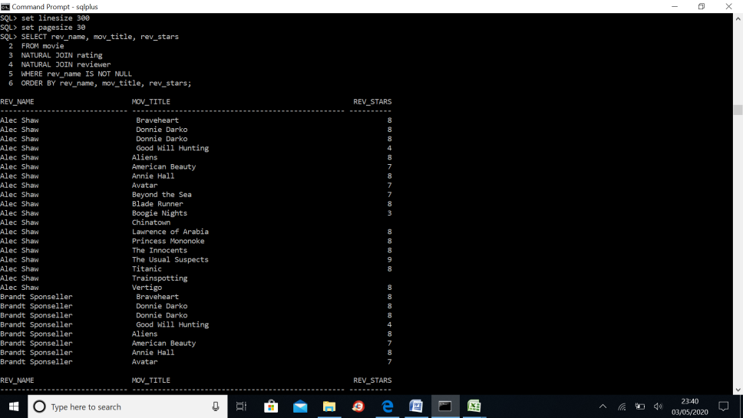

1. Write a query in SQL to find movie title and number of stars for each movie that has at least one rating and find the highest number of stars that movie received and sort the result by movie title.

SELECT mov_title, MAX(rev_stars)

FROM movie

INNER JOIN rating USING(mov_id)

GROUP BY mov_title

HAVING MAX(rev_stars)>0

ORDER BY mov_title;



1. Write a query in SQL to find the movie title, actor first and last name, and the role for those movies where one or more actors acted in two or more movies.

SELECT mov_title, act_fname, act_iname, role

FROM movie

JOIN movie_cast

ON movie_cast.mov_id=movie.mov_id

JOIN actor

ON movie_cast.act_id=actor.act_id

WHERE actor.act_id IN (

SELECT act_id

FROM movie_cast

GROUP BY act_id HAVING COUNT(*)>=2);

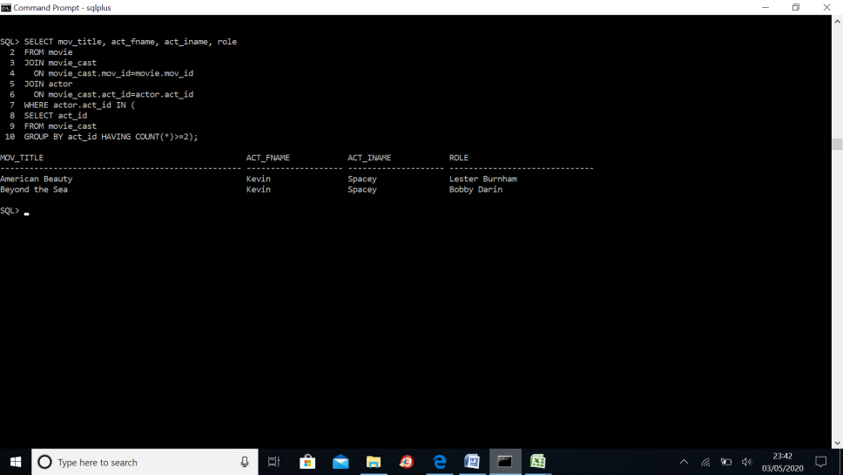

1. Write a query in SQL to find the first and last name of a director and the movie he or she directed, and the actress appeared which first name was Claire and last name was Danes along with her role in that movie.

SELECT dir_fname, dir_iname, mov_title, act_fname, act_iname, role

FROM actor

JOIN movie_cast

ON actor.act_id=movie_cast.act_id

JOIN movie_direction

ON movie_cast.mov_id=movie_direction.mov_id

JOIN director

ON movie_direction.dir_id=director.dir_id

JOIN movie

ON movie.mov_id=movie_direction.mov_id

WHERE act_fname='Claire'

AND act_iname='Danes';

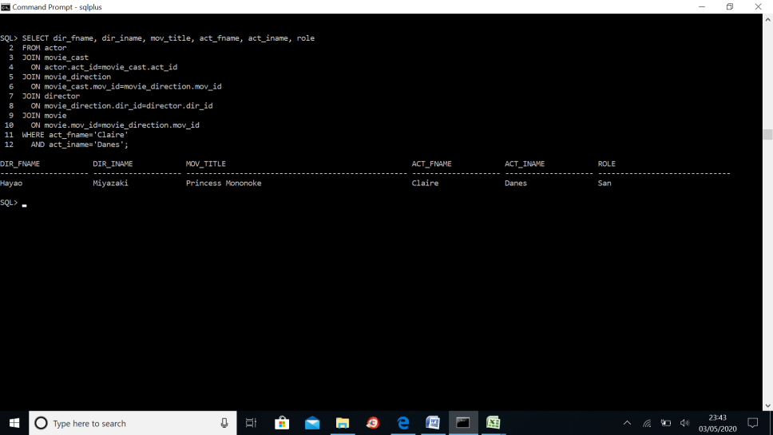

1. Write a query in SQL to find the first and last name of an actor with their role in the movie which was also directed by themselves.

SELECT act_fname, act_iname, mov_title, role

FROM actor

JOIN movie_cast

ON actor.act_id=movie_cast.act_id

JOIN movie_direction

ON movie_cast.mov_id=movie_direction.mov_id

JOIN director

ON movie_direction.dir_id=director.dir_id

JOIN movie

ON movie.mov_id=movie_direction.mov_id

WHERE act_fname=dir_fname

AND act_iname=dir_iname;

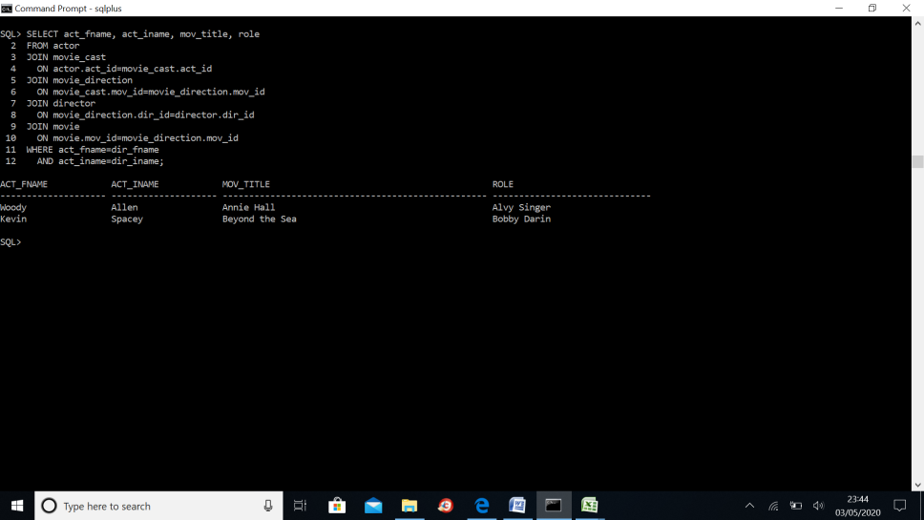

1. Write a query in SQL to find the cast list for the movie Chinatown.

SELECT a.act_fname, a.act_iname

FROM

movie_cast c

JOIN actor a ON

c.act_id = a.act_id

Where mov_id = (

SELECT mov_id

FROM movie

Where mov_title = 'Chinatown');

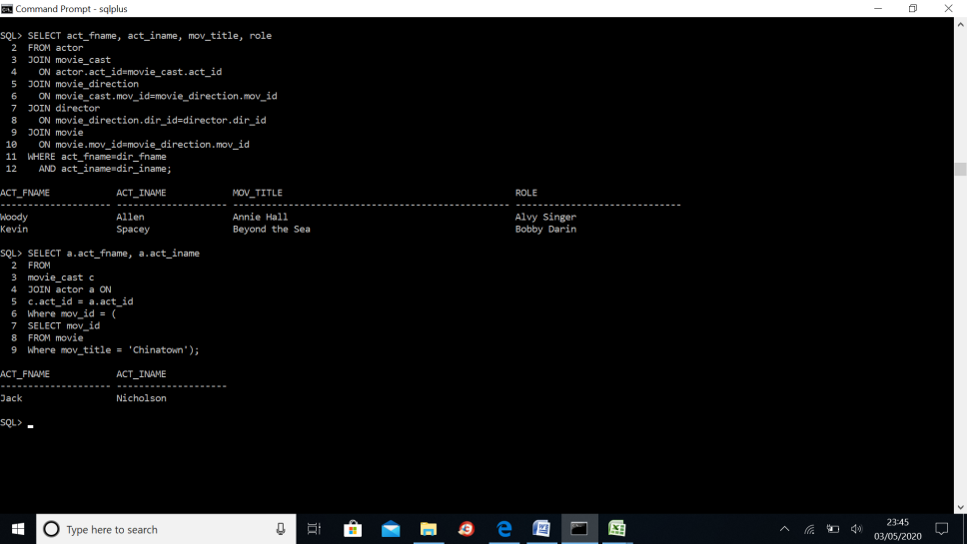

1. Write a query in SQL to find the movie in which the actor appeared whose first and last name are 'Harrison' and 'Ford'.

SELECT m.mov_title

FROM movie m

JOIN movie_cast c

ON m.mov_id = c.mov_id

WHERE c.act_id IN (

Select act_id

FROM actor

WHERE act_fname='Harrison'

AND act_iname='Ford');



1. Write a query in SQL to generate a report which shows the year when most of the Mystery movies produces, and number of movies and their average rating.

SELECT mov_year,gen_title,count(gen_title), avg(rev_stars)

FROM movie

NATURAL JOIN movie_generes

NATURAL JOIN genres

NATURAL JOIN rating

WHERE gen_title='Mystery'

GROUP BY mov_year,gen_title;



1. Write a query in SQL to generate a report which contain the columns movie title, name of the female actor, year of the movie, role, movie genres, the director, date of release, and rating of that movie.

SELECT mov_title, act_fname, act_iname,

mov_year, role, gen_title, dir_fname, dir_iname,

mov_dt_rel, rev_stars

FROM movie

NATURAL JOIN movie_cast

NATURAL JOIN actor

NATURAL JOIN movie_generes

NATURAL JOIN genres

NATURAL JOIN movie_direction

NATURAL JOIN director

NATURAL JOIN rating

WHERE act_gender='F';

1. Write a query in SQL to find the highest-rated Mystery movie, and report the title, year, and rating.

SELECT mov_title, mov_year, rev_stars, mov_rel_country FROM movie NATURAL JOIN rating WHERE rev_stars = ( SELECT MAX(rev_stars) FROM rating );



1. Write a query in SQL to find the highest-rated movie, and report its title, year, rating, and releasing country.

SELECT mov_title, mov_year, rev_stars, mov_rel_country FROM movie NATURAL JOIN rating WHERE rev_stars = ( SELECT MAX(rev_stars) FROM rating );



1. Write a query in SQL to find the cast list for the movie The Shawshank Redemption.

